

Optimizing User, Group, and Role Management with Access Control and Workflows

DAY 5 PROJECT DOCUMENTATION



**TEAM MEMBERS**

**SANJAY.E**

**POOVARASAN.M**

**PASUPATHI.E**

**PRABANJAN.S**

|  |  |  |
| --- | --- | --- |
| **S.NO** | **TABLE OF CONTENT** | **PAGE NO** |
| **1.** | **USERS** | **2** |
| **2.** | **GROUPS** | **4** |
| **3.** | **ROLES** | **5** |
| **4.** | **TABLES** | **7** |
| **5.** | **ASSIGN USERS TO GROUPS** | **9** |
| **6.** | **ASSIGN ROLES TO USERS** | **10** |
| **7.** | **APPLICATION ACCESS** | **12** |
| **8.** | **ACCESS CONTROL LIST** | **13** |
| **9.** | **FLOW** | **15** |
| **10.** | **CONCLUSTION** | **20** |

**PROBLEM STATEMENT:**

In a small project management team consisting of a Project Manager (Alice) and a Team Member (Bob), there is a need to efficiently manage project tasks and ensure accountability throughout the project lifecycle. The current system lacks clear role definitions, access controls, and a structured workflow, leading to confusion regarding task assignments and progress tracking.

**SPECIFIC OBJECTIVES:**

**I. USER ROLE:**

* Establish distinct roles for Alice (Project Manager) and Bob (Team Member) to ensure clarity in responsibilities and access rights within the project management tool.

**II.ACCESS CONTROL (ACL):**

* Create a system that restricts Bob’s access to project creation and editing features while allowing him to view and update his assigned tasks, there by preventing unauthorized changes.

**III.WORKFLOW PROCESSES:**

* Develop a structured workflow for task assignment and progress tracking, ensuring that Alice can easily assign tasks to Bob and monitor their completion in a timely manner.

**TASK INITIALIZATION:**

**Users:**

**Activity 1: Create Users**

1**.** Open ServiceNow

2. Click on All >> search for tables

3. Select Users Under System security

4. Click On New

5. Fill the following details to create a new user

6. User ID: Alice

7. Click on Submit.

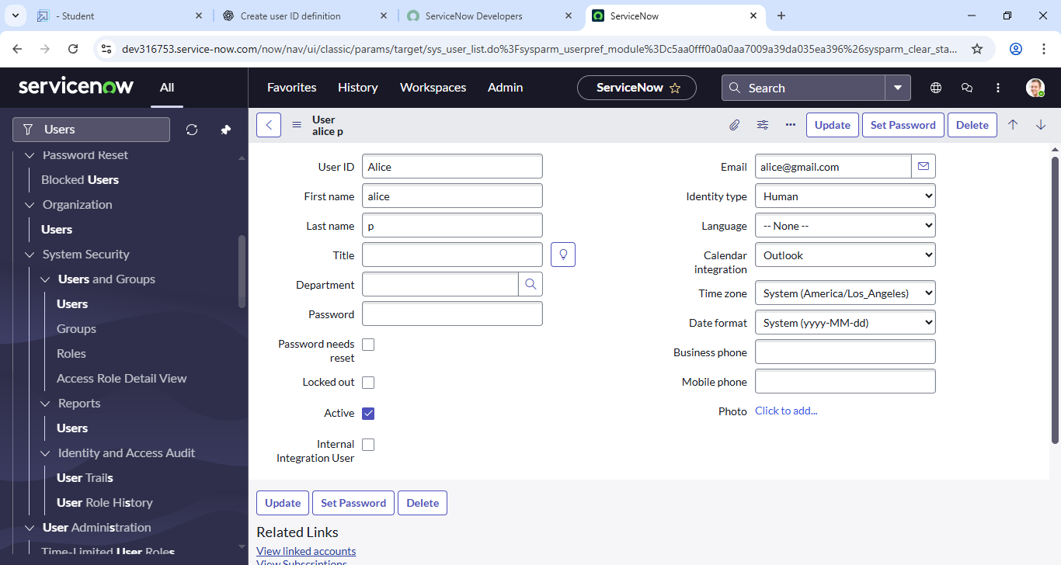

The User ID is a unique username assigned to a user within the ServiceNow platform. It is used for logging in and for identifying the user in system records, tasks, and workflows.

In this case, setting User ID: Alice means you're creating a new user with the identifier "Alice". This ID must be:

* Unique across the system (no two users can have the same User ID).
* Typically short and easy to remember
* Often based on the person’s name, employee ID, or organizational standard

**Activity 2:**

1. Create another user with the following details User ID: Bob

2. Click on submit.

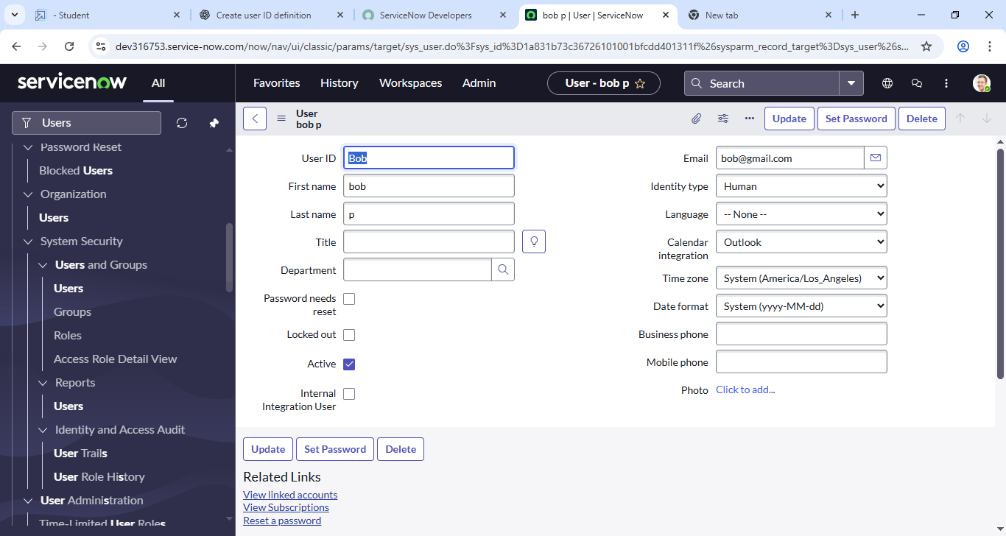

**Groups:**

**Activity: Create Groups**

1. Open ServiceNow

2. Click on All >> search for groups

3. Select groups under system security

4. Click on new

5. Fill the following details to create a new group

6. Group Name: Project Team

7. Click on submit

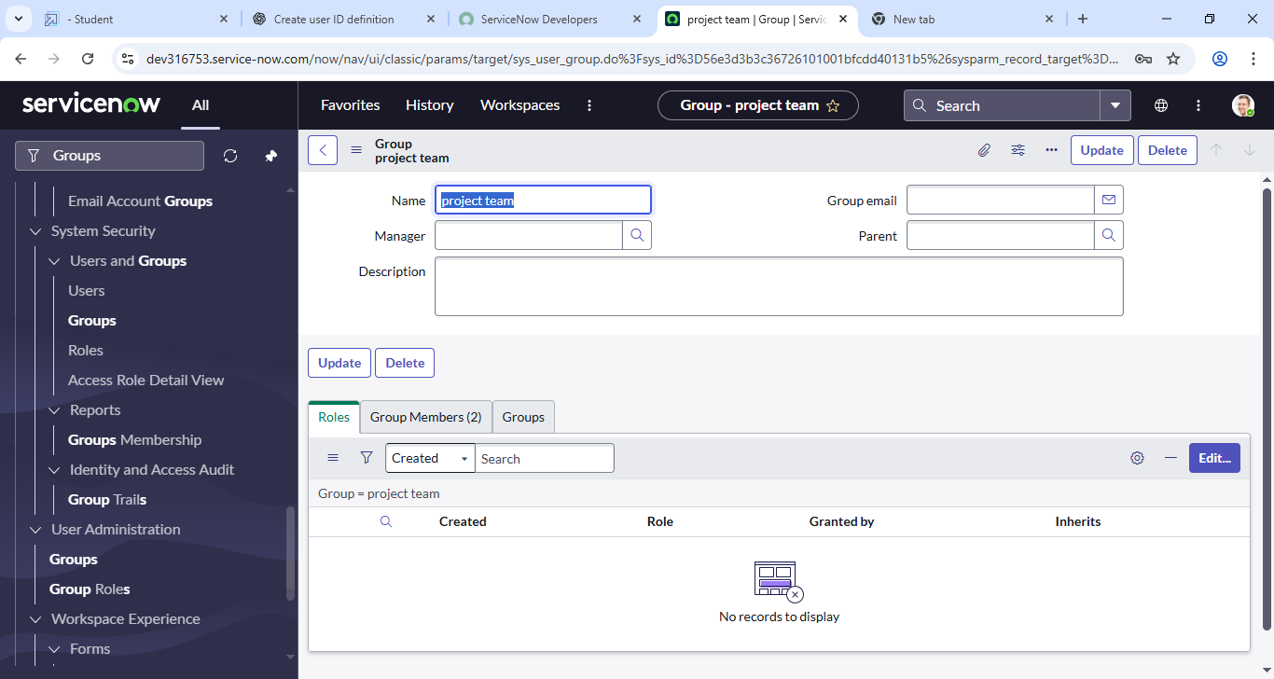

**Definition:**

The Group Name is the title or label that identifies the group within the ServiceNow system. In this activity, you are creating a group with the name **"**Project Team**"**.

This group will represent a team of users working on a specific project or set of tasks. Assigning users to this group allows ServiceNow to:

* Route tasks and tickets to the group
* Use the group in workflows, approvals, or escalations
* Apply group-level roles and permissions.

**Roles:**

**Activity 1: Create Roles**

1.Open service now.

2. Click on All >> search for roles

3. Select roles under system security

4. Click on new

5. Fill the following details to create a new role

6. Role Name: Project Member

7. Click on submit



The Role Name is the unique identifier or title for the role you are creating. In this activity, you're creating a role called **"**Project Member**"**.

This role can be used to:

* Grant specific access and permissions to users working on a project
* Control visibility and actions within ServiceNow modules like Incident, Change, or Project Management
* Be assigned to individual users or to a group (e.g., the **Project Team** group you created earlier)

**Activity 2:**

1. Create another role with the following details
2. Role Name: Team Member
3. Click on submit

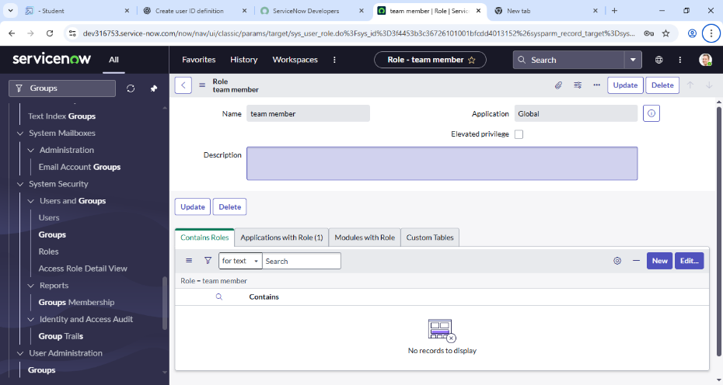

**Definition:**

The Role Name is the unique label used to identify the role. In this activity, you are creating a role called "Team Member".

This role is typically used to:

* Represent general team members involved in tasks or operations
* Provide access to specific features relevant to their duties
* Control visibility to data and actions (such as viewing tasks, updating records, or participating in workflows)

**Tables:**

**Activity 1: Create Table**

1. Open service now
2. Click on All >> search for tables
3. Select tables under system definition
4. Click on new
5. Fill the following details to create a new table

* Label: project table
* Check the boxes Create module & Create mobile module

1. New menu name: project table
2. Table columns give the columns
3. Click on submit

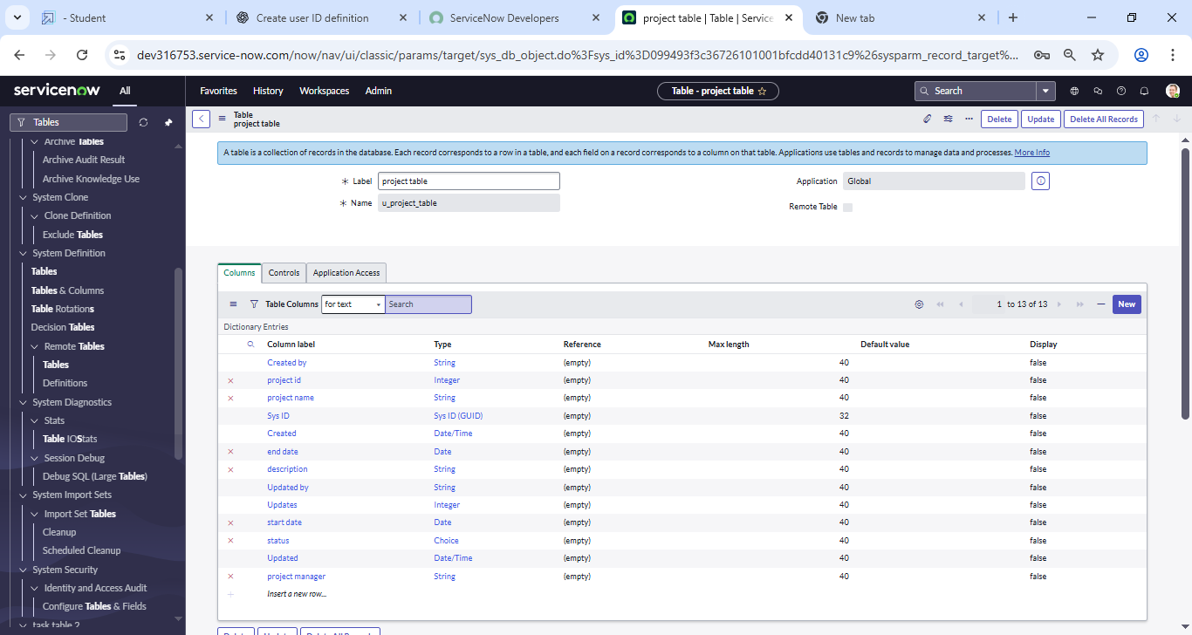

1. Label:

* Definition:

The Label is the display name of the table. This is the name users will see in the ServiceNow UI (e.g., in the navigation pane or when searching).

* Example:

If you enter Project Table as the label, the system will automatically generate the table name as u_project_table (the u_ prefix indicates a custom table).

2. Check the boxes:

* Create module:
* Definition: Adds a link to the table in the application navigator under the selected application menu.
* Purpose: Allows users to easily access the table records.
* Create mobile module:
* Definition: Creates a mobile-friendly version of the module for access via the ServiceNow mobile app.
* Purpose: Enables mobile users to access and interact with the table.

3.New menu name:

* Definition:

This is the name of the application menu under which your new table will appear in the left-hand navigation

* Example:

If you set this to Project Table, users will find the table and its modules under that section in the navigator.

4.Table Columns:

* You will define the structure of the table by adding **columns** (also called fields). Each column represents a piece of data you want to store in the table.

**Activity 2:**

1. Create another table fill with following details.
2. Lable Name: task table 2
3. Click on submit.

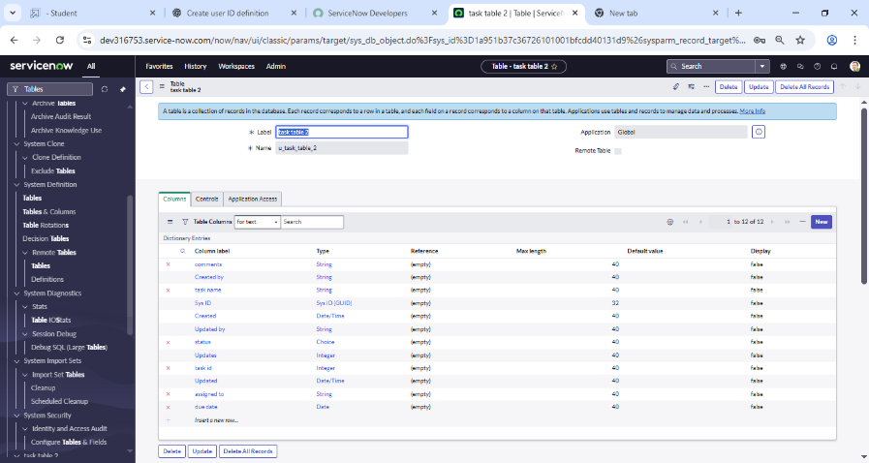

1. Label:

* Definition:

The Label is the user-friendly display name of the table. This name will appear in the application navigator and list views.

* System Table Name Generated:

When you enter task table 2 as the Label, ServiceNow automatically creates the table with the name u_task_table_2.

1. Click on Submit:

* Definition:

Clicking Submit saves and creates the new table in the system with the defined label.

* Result:

The table is now available in ServiceNow and can be accessed via the Application Navigator (if a module was created) or through system tables.

**Assign users to groups:**

**Activity: Assign users to project team group**

1. Open service now.
2. Click on All  >> search for groups
3. Select tables under system definition
4. Under group members
5. Select the project team group
6. Click on edit
7. Select  alice p and bob p
8. Click on save.

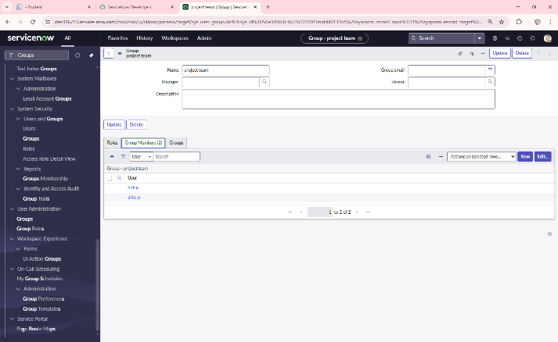

**Definition:**

Assigning users to a group in ServiceNow is the process of adding specific users to a predefined group so they can inherit the group’s responsibilities, roles, and permissions. In this activity, the *Project Team Group* is selected, and users (*Alice P* and *Bob P*) are added as group members. This ensures that both users become part of the project team and can collaborate, receive assignments, and access resources associated with that group.

**Assign roles to users:**

**Activity 1: Assign roles to alice user**

1. Open ServiceNow
2. Click on All >> search for user
3. Select tables under system definition
4. Select the Alice p User
5. Under Roles
6. Click on edit
7. Select project member
8. Click to save
9. Click on edit add u_project_table role and u_task_table role
10. Click on save
11. Update the form.

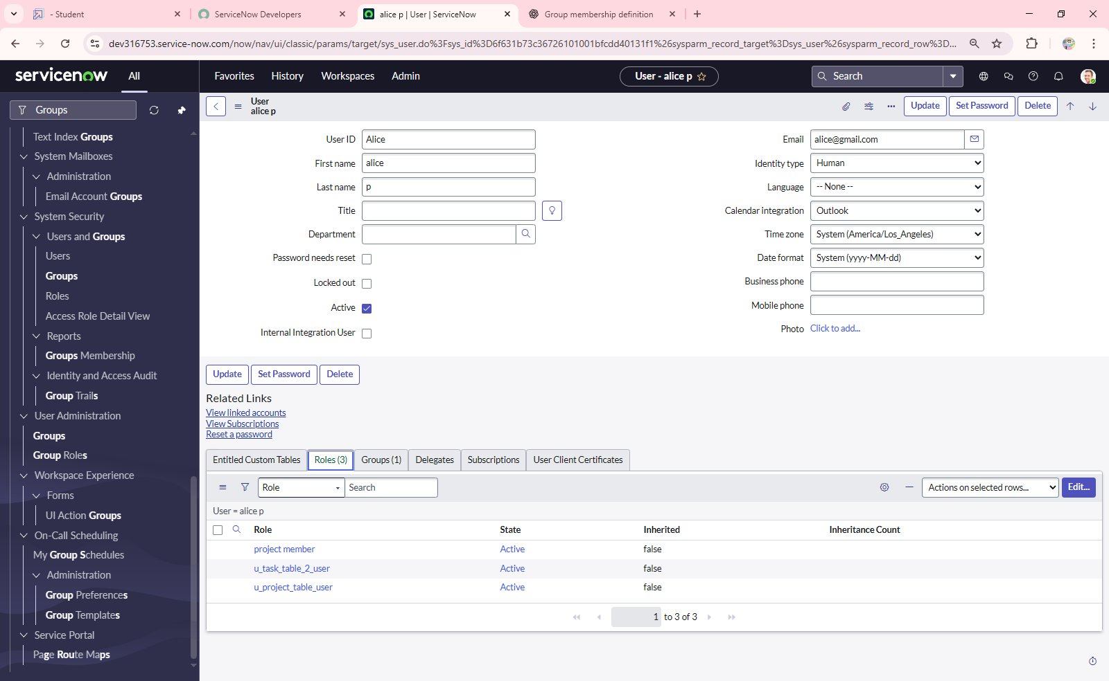

**Definition:**

Assigning roles to a user in ServiceNow is the process of granting specific permissions that control what the user can view or perform within the platform. In this activity, the user *Alice P* is selected, and roles such as *Project Member*, *u_project_table*, and *u_task_table* are assigned. This ensures Alice has the necessary access rights to manage project-related tasks and interact with the corresponding tables. Updating the form finalizes the role assignment and applies the changes to the user profile.

**Activity 2: Assign roles to Bob user**

1.Open ServiceNow

2.Click on All >> search for user

3. Select tables under system definition

4. Select the Bob User

5. Under Roles

6. Click on edit

7. Select team member and give table role

8.Click on save

9. Click on profile icon Impersonate user to bob

10. We can see the task table2.

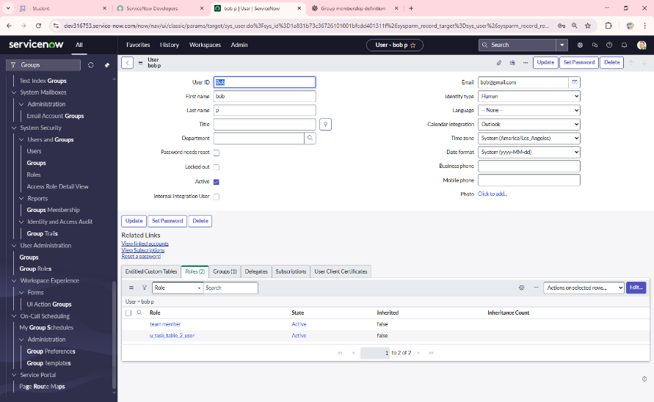

**Definition:**

Assigning roles to a user in ServiceNow provides them with the necessary permissions to access specific features, tables, and functionalities. In this activity, the user *Bob* is selected and assigned the *Team Member* role along with a table role. After saving the changes, impersonating Bob allows validation that the assigned roles are active. By impersonating, the administrator can confirm that Bob now has access to the *Task Table2*, ensuring that the correct roles have been successfully applied.

**Application access:**

**Activity:** **Assign table access to application**

1. while creating a table it automatically create a application and module for that table
2. Go to application navigator search for search project table application
3. Click on edit module
4. Give project member  roles to that application
5. Search for task table2 and click on edit application.
6. Give the project member and team member role for task table 2 application

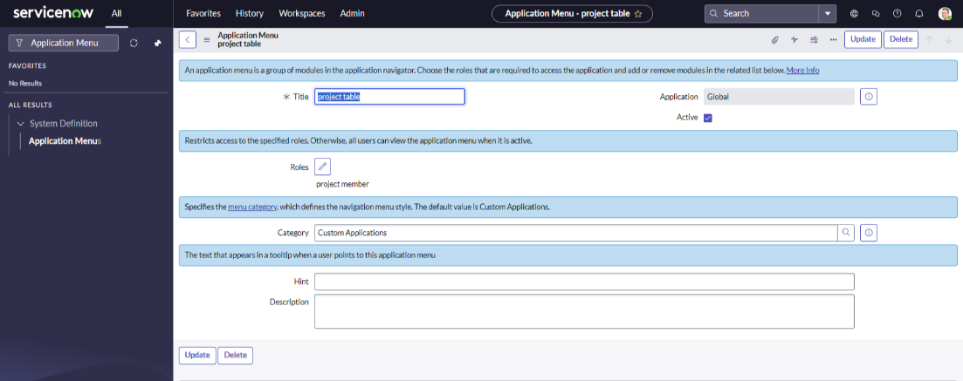

1. Click on edit task table 2 module

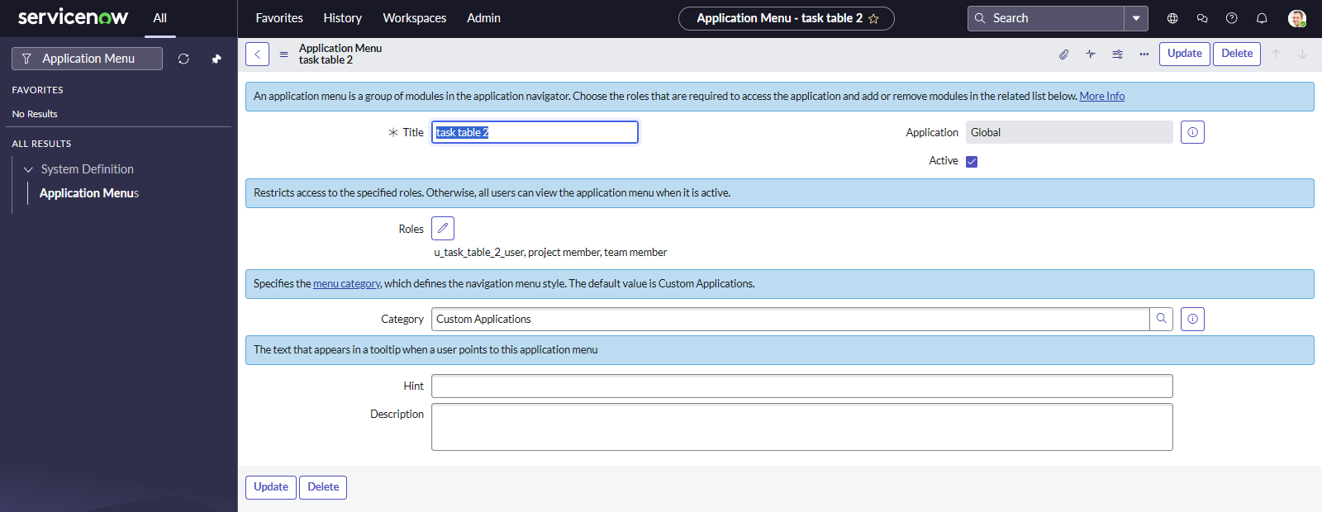

**Access control list:**

**Activity: Create ACL**

1. Open service now
2. Click on All >> search for ACL
3. Select Access Control (ACL) under system security
4. Click on elevate role
5. Click on new
6. Fill the following details to create a new ACL

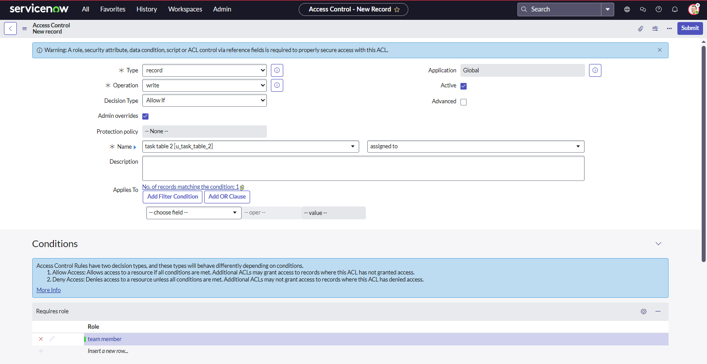

1. Scroll down under requires role
2. Double click on insert a new row
3. Give task table and team member role
4. Click on submit
5. Similarly create 4 ACL for the following fields

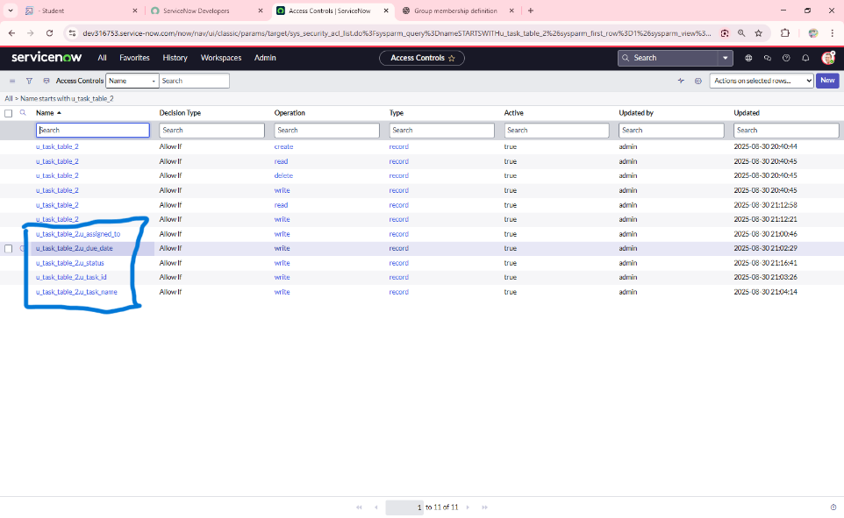

1. Click on profile on top right side
2. Click on impersonate user
3. Select  Bob user
4. Go to all and select task table2 in the application menu bar
5. Comment and status fields are have the edit access

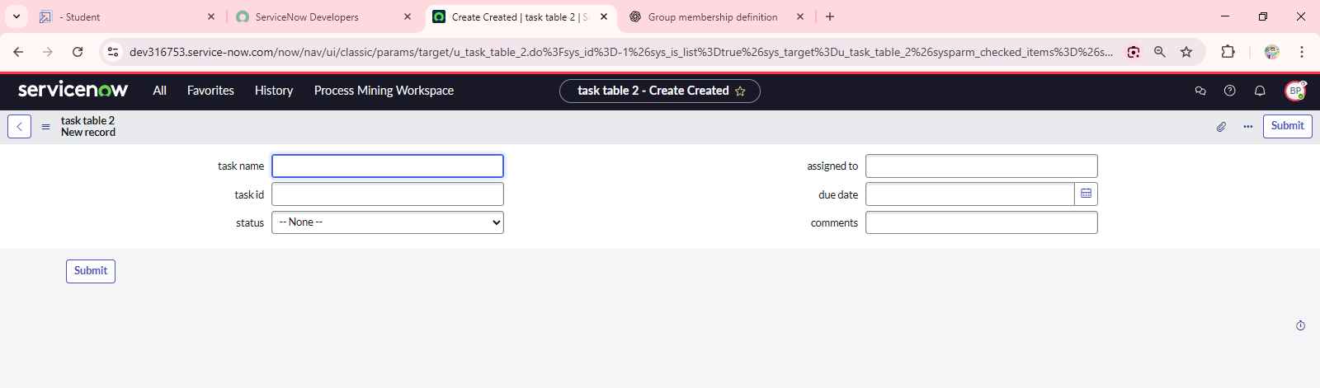

**Definition:**

An Access Control List (ACL) in ServiceNow defines security rules that restrict access to tables, fields, and records by evaluating conditions, roles, and scripts. Creating an ACL ensures that only authorized users with the specified roles can access or modify data.

In this activity, a new ACL is created for the *Task* table and assigned to the *Team Member* role. This restricts access so that only users with the *Team Member* role can edit or interact with the defined table fields. By impersonating the *Bob* user (who has the *Team Member* role), it can be validated that Bob has edit access to the *Comment* and *Status* fields of *Task Table2*.

This confirms that the ACL is working as expected and enforcing role-based access to data.

**Flow Designer:**

**Activity: Create a Flow to Assign operations ticket to group**

1**.** Open service now.

2. Click on All >> search for Flow Designer

3. Click on Flow Designer under Process Automation.

4. After opening Flow Designer Click on new and select Flow.

5. Under Flow properties Give Flow Name as “task table”.

6. Application should be Global.

7. Click build flow.

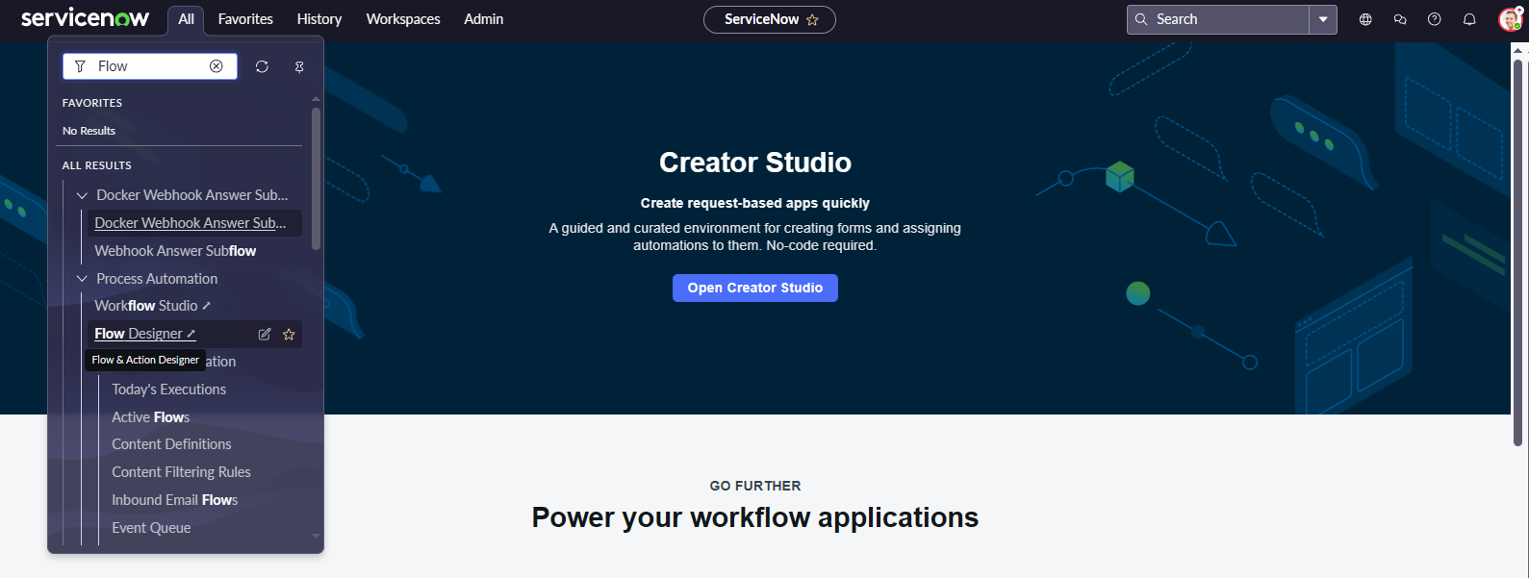

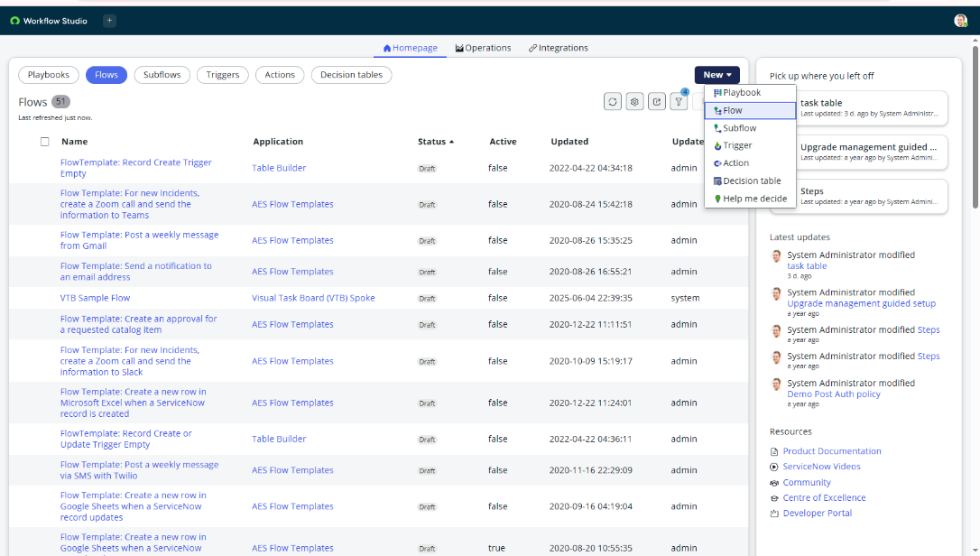

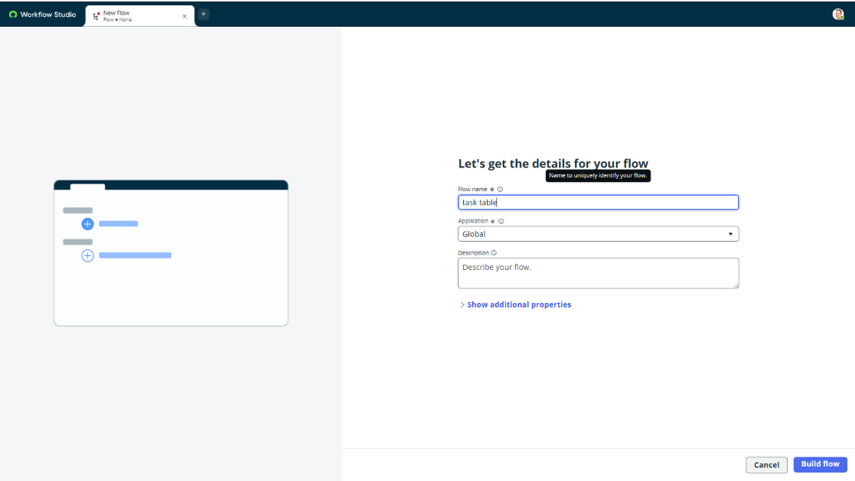

**Activity 2:**

1. Click on Add a trigger
2. Select the trigger in that Search for “Create  Record”  and select that.
3. Give the table name as “ task table ”.
4. Give the Condition as Field : status Operator :is Value : in progress

                                   Field : comments Operator :is Value : feedback

                                   Field : assigned to Operator :is Value : bob

1. After that click on Done.

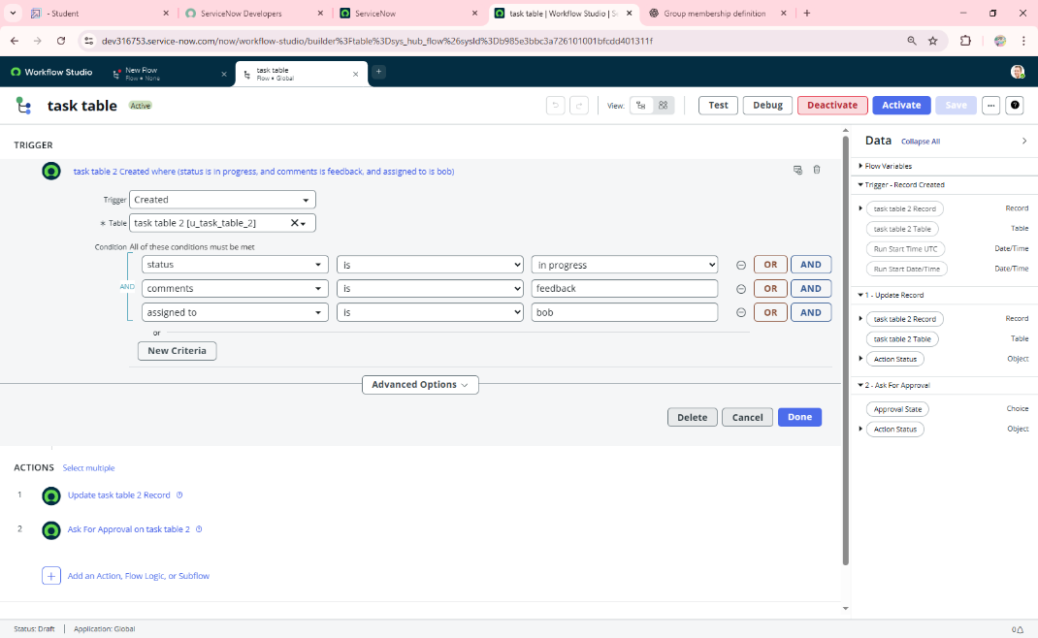

**Activity 3:**

1. Click on Add an action.
2. Select action in that, search for “update records”.
3. In Record field drag the fields from the data navigation from Right Side (Data pill)
4. Table will be auto assigned after that
5. Add fields as “status” and value as “completed”
6. Click on Done.

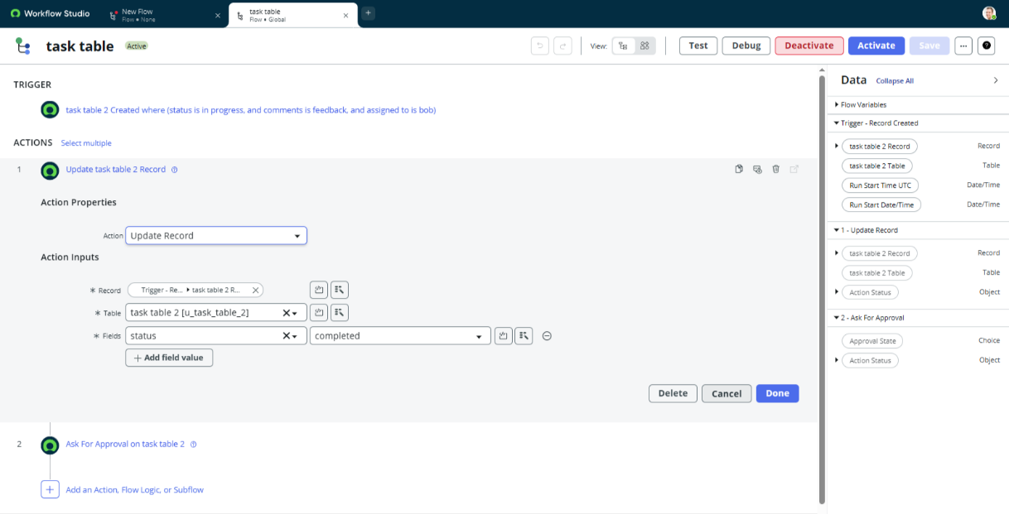

**Activity 4:**

1. Now under Actions.
2. Click on Add an action.
3. Select action in that, search for “ask for approval”.
4. In Record field drag the fields from the data navigation from Right side
5. Table will be auto assigned after that
6. Give the approve field as “status”
7. Give approver as alice p
8. Click on Done.

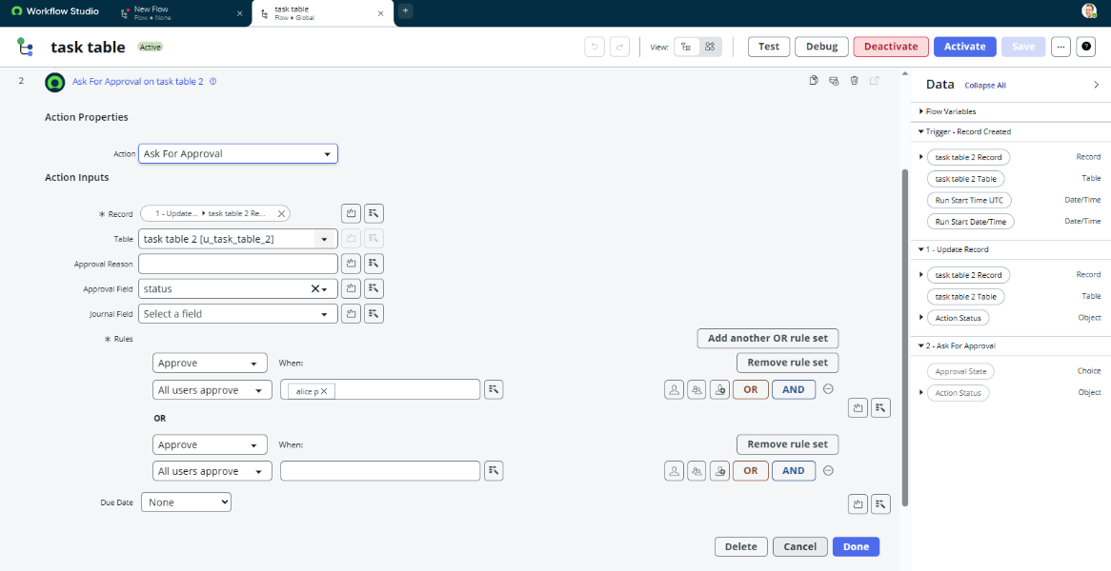

1. Go to application navigator search for task table.
2. It status field is updated to completed.

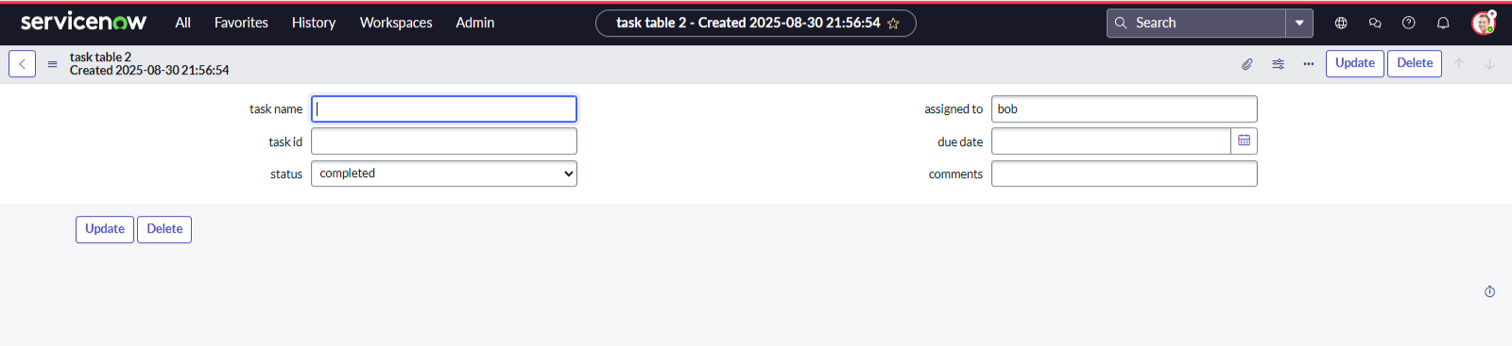

1. Go to application navigator and search for my approval
2. Click on my approval under the service desk.
3. Alice p got approval request then right click on requested then select approved .

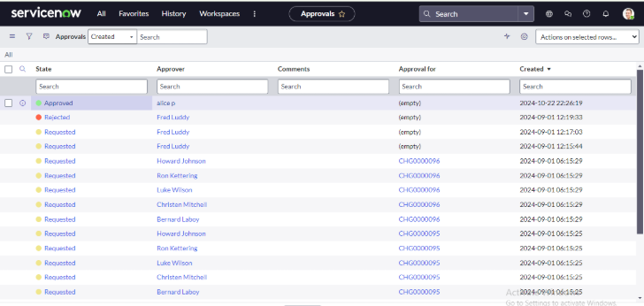

**Definition:**

A Flow in Flow Designer is an automated process in ServiceNow that executes actions based on defined triggers and conditions without writing code. It helps streamline business processes by assigning tasks, updating records, and sending approvals automatically.

In this activity, a flow is created for the *Task Table* to manage operations tickets. The flow is triggered when a new record is created in the Task Table with conditions: *status = in progress*, *comments = feedback*, and *assigned to = Bob*. Once triggered, the flow performs two actions:

1. Update Records – It changes the *status* field of the task to *completed*.
2. Ask for Approval – It sends an approval request to *Alice P*, allowing her to review and approve the task update.

After execution, the *Task Table* record’s status updates to *Completed*, and an approval request is generated in *My Approvals*. When Alice P approves the request, it confirms successful automation of task assignment and completion using Flow Designer.

**Conclusion:**

This scenario highlights a structured approach to project management, showcasing the roles of Alice and Bob within a defined workflow. With Alice's oversight and Bob's execution, the team effectively collaborates to ensure project success. The use of tables organizes key information, facilitating easy tracking of projects, tasks, and progress updates. Overall, this system promotes accountability, enhances communication, and leads to the successful completion of projects.

THANKING YOU